**Ms. Hickman: Gifted Kindergarten**

**Supply List 2014/2015**

1 backpack (labeled)

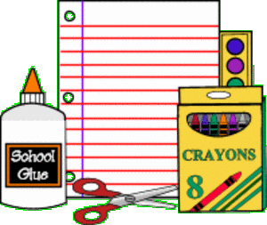

1 box of 24 sharpened pencils

1 pack of rectangle/square erasers

1 box of colored pencils

4 glue sticks

4 2-pocket folders (labeled)

4 1-subject **spiral** notebook (**wide ruled**)

2 rolls of paper towels

2 boxes of Kleenex (family size)

2 bottles hand sanitizer

2 containers of anti-bacterial Lysol/Clorox wipes

1 ream **white** **copy** paper, 8 ½ X 11"

1 ream **colored** **copy** paper, 8 ½ X 11” (any color)

1 box of Band-Aids (any kind or decoration)

1 box of sandwich, quart or gallon Ziploc bags (choose any size)

*Parents may be asked to replenish supplies throughout the school year.*

*Please label your child’s book bag, folders and notebooks.*

[anhickman@cps.edu](mailto:anhickman@cps.edu)